EXPT NO:6 | OVER-PLOTTING REDUCTION TECHNIQUES
DATE: 09.02.2026 | OVER-PLOTTING REDUCTION TECHNIQUES

PRE-LAB QUESTIONS

- Why is over-plotting common in big data visualization?

Over-plotting occurs because large datasets contain thousands or millions of data points that overlap in the same visual space. When many points are drawn on a chart (especially scatter plots), they stack on top of each other, making it hard to distinguish individual values or patterns.

- How does data density affect perception?

High data density makes visualizations appear cluttered and crowded, which reduces readability. Important patterns, clusters, or outliers may become difficult to notice, leading to misinterpretation of the data.

- What trade-offs exist between detail and clarity?

Showing more detail increases accuracy and completeness but can make the visualization complex and harder to understand. Reducing detail improves clarity and readability but may hide useful information or small patterns.

- How do AI datasets increase visualization complexity?

AI datasets are usually very large, high-dimensional, and contain many variables. Visualizing such data requires handling more points, features, and relationships, which increases clutter and makes it harder to present insights clearly.

- Why is over-plotting a serious analytical risk?

Over-plotting can hide trends, patterns, and outliers, leading to incorrect conclusions. When data overlaps too much, analysts may miss important insights or misinterpret the actual distribution of the data.

IN-LAB EXERCISE:

OBJECTIVE:

To apply techniques that reduce visual clutter in large-scale datasets.

SCENARIO:

A social media analytics company visualizes millions of user interactions to study engagement patterns.

IN-LAB TASKS (Using R Language)

• Apply alpha blending
• Implement jittering techniques
• Use aggregation and binning

Code:

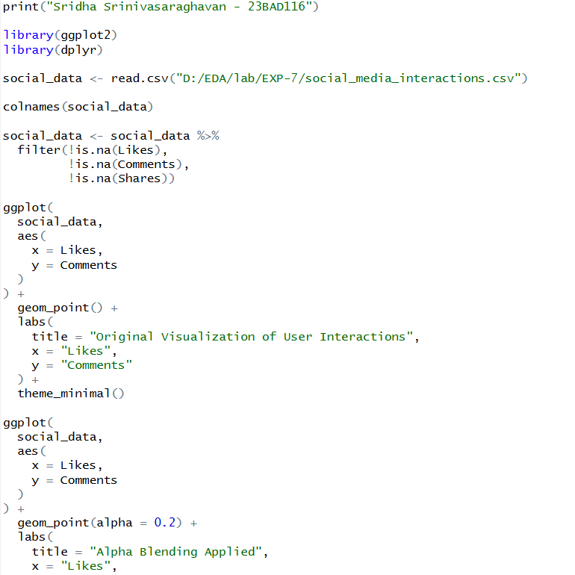
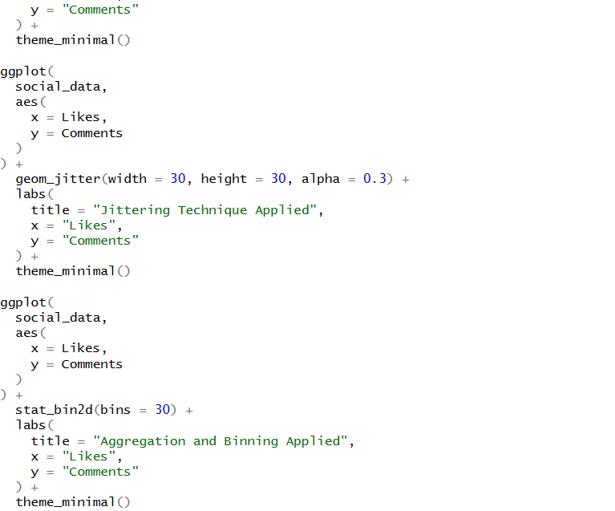

Output:

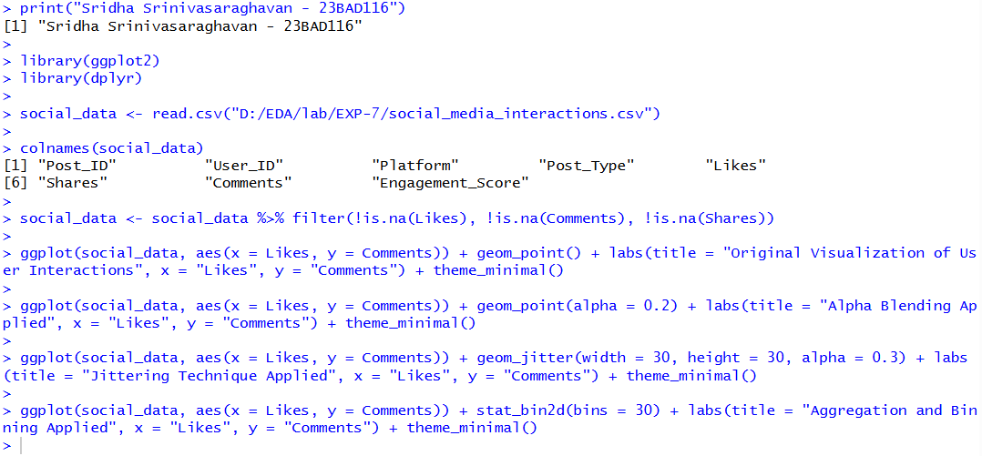

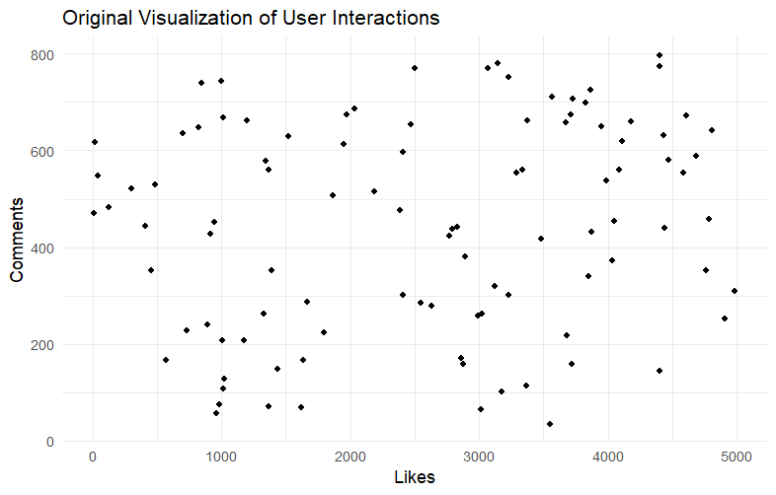

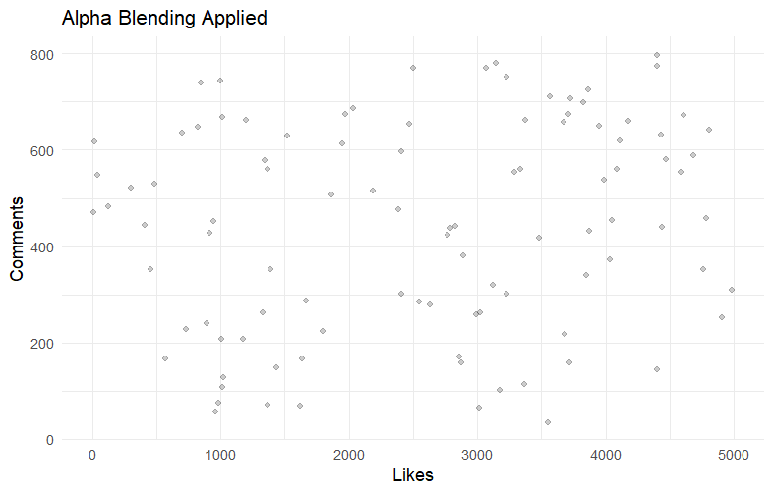

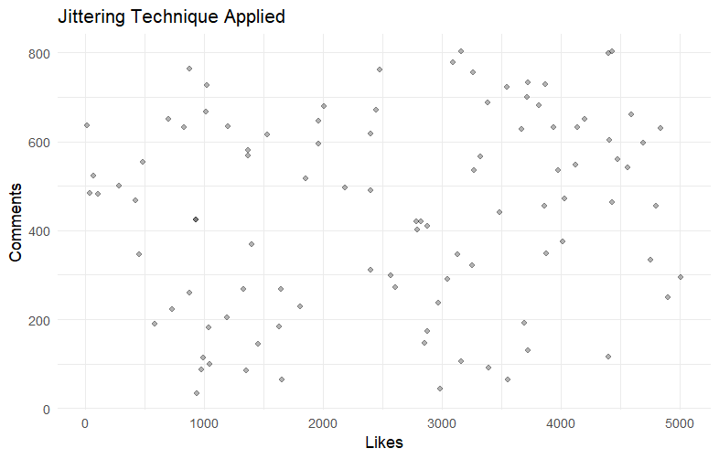

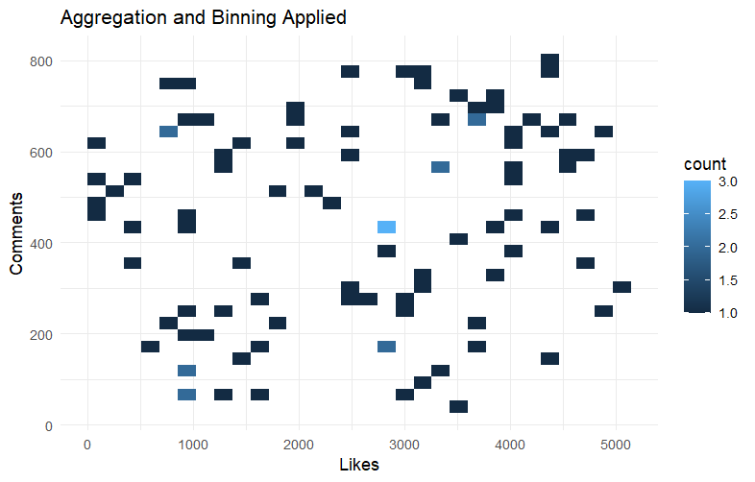

POST-LAB QUESTIONS

- Which technique provided the best clarity and why?

Aggregation and binning usually provide the best clarity because they group large numbers of overlapping points into summarized blocks, making dense patterns, clusters, and trends clearly visible. Alpha blending helps reveal density, and jittering separates overlapping points, but aggregation gives a cleaner overall structure for very large datasets.

- How does over-plotting distort analytical conclusions?

Over-plotting hides the true distribution of data by stacking many points on top of each other. This can make dense areas look less significant, conceal outliers, and create a false impression that values are evenly spread, leading to incorrect interpretations and decisions.

- When should aggregation be preferred over raw plotting?

Aggregation should be used when dealing with very large datasets where individual points overlap heavily. It is especially useful when the goal is to understand overall trends, density patterns, or clusters rather than individual data values.

- How do these techniques support scalable AI analytics?

Techniques like alpha blending, jittering, and aggregation help handle massive datasets by improving readability without removing important information. They allow analysts to explore patterns, detect anomalies, and interpret model-related data more efficiently, which is essential when working with large-scale AI datasets.

- Explain real-world consequences of ignoring over-plotting.

Ignoring over-plotting can lead to missed insights, hidden trends, and wrong business decisions. For example, a company may fail to identify highly engaged users, overlook performance issues, or misjudge customer behaviour, resulting in poor strategy planning and financial loss.

LEARNING OUTCOME: Students master over-plotting reduction for big data visual analytics.
ASSESSMENT
Description | Max Marks | Marks Awarded
Pre Lab Exercise | 5
In Lab Exercise | 10
Post Lab Exercise | 5
Viva | 10
Total | 30
Faculty Signature

